Chapter 3, Problem 28.

Use MATLAB to find the voltages at nodes a, b, c, and d in the circuit of Fig. 3.77.

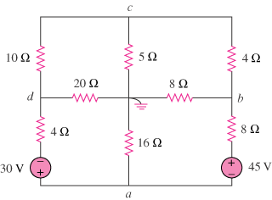
60 V
90 V

Figure 3.77
For Prob. 3.28.

